Document Accessibility

Microsoft – Ease of Access
This provides built in assistive technology and can be found via ‘Start’ > Settings:

1. Vision
- Display
- Cursor & pointer
- Magnifier
- Colour filters
- High contrast
- Narrator

2. Hearing
- Audio
- Closed captions

3. Interaction
- Speech
- Keyboard
- Mouse
- Eye control

8 Steps to create Accessible Documents
- Document properties
- Headings & structure
- Font
- Colour & contrast
- Layout
- Alternative text for images
- Hyperlinks
- Tables
Document Properties
It is important for search engines & screen readers to be able to identify the contents in your documents. By inserting Title, tags, author and Company this makes your document easier to identify.
‘File’ – click on the info you want to add to the document properties (right hand side)
Headings & Structure
Create headings using the built-in ‘Heading Styles’, on the ‘Home’ ribbon. They can be modified (right click).
To check the heading structure of your document you can use the Navigation Pane – ‘View’ ribbon > tick box for Navigation Pane. This is also useful to a person who is dyslexic.

Font
The recommended typeface is Sans serif as it is easier to read – Arial, Verdana, Tahoma or Calibri. These fonts have consistent thickness, are plan and smooth.
Do not use upper case for whole words or sentences, use sentence case.
Use a capital letter for each word of a heading.
Use bold instead of italic or underlining.
Font size 12 for normal text or size 18 for large.

Colour & Contrast
Colour contrast analyser – Paciello Group (Europe) and available through Vision Australia:
Vision Australia website and colour contrast anyalyser information
The Colour Contrast Analyser is useful to help determine the legibility of text on a web page or document, and the legibility of image based representations of text.

Layout
Line spacing should be 1.2 for 12 point font (normal) and 1.5 for 14 point font and above.
You can change the line spacing in the ‘Home’ ribbon – Paragraph 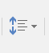 tab
Always use left alignment as it creates even spacing between words. Other alignment options create uneven space between words and makes it hard to read, for some people, left to right, without jumping from line to line.
Use the built in list options – bullet points or numbers.
Do not use text boxes as the information contained in the text book is disregarded by a screen reader. Use bold to highlight important information.

Alternative text for Images
This provides an image description which is extremely useful for anyone using a screen reader.
The image must be ‘in line’ with text – ‘layout’ ribbon > ‘Arrange’ section > Position tab >
right click on image > format picture > layout & properties (3rd tab) > alt text > add description

Hyperlinks
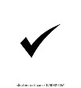
Hyperlinks should provide a description and not simply be the URL address:
Link to Greater Dandenong Volunteer Resource Service website
http://gdvrs.org.au
Right click on the hyperlink > edit hyperlink > provide description in ‘text to display’.
Avoid using ‘click here’ or ‘further info’ as this does not provide any information on where this hyperlink will take you.

Tables
Ensure your tables are simple and avoid merged or split cells.
Add alternative text to your table to provide a description for a screen reader – highlight whole table & right click – table properties – alt text – add description.
Ensure a header row will reappear if the table goes across more than one page – highlight header row – ‘Layout’ ribbon (Table Tools next to Design) – Properties (Table section of ribbon) - click on Row tab – Options – Click on ‘repeat as header row of each page’

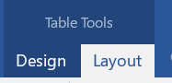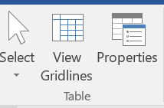

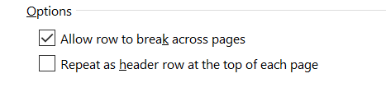

Check Website Accessibility

Web Accessibility Evaluation Took website link
Site Improve website to check accessibility of your website
Website accessibility analyser

