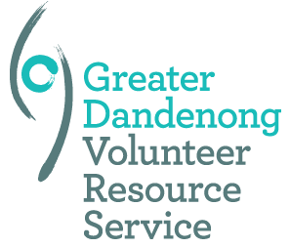
Greater Dandenong Volunteer Resource Service
Recognition Ceremony 2015 for Voluntary Organisations
Nomination Form

The Greater Dandenong Volunteer Resource Service, in partnership with the City of Greater Dandenong, is hosting an event to recognise the important work performed by volunteers who work in local community organisations and to highlight success stories.

Nominations are invited from local community organisations and business that work with volunteers. We are looking for local organisations that have a commitment to supporting and engaging with volunteers and who contribute to the culture, vibrancy and health and wellbeing of the City of Greater Dandenong.

The closing date for nominations will be 5.30pm Wednesday, 30 October 2015.

Representatives from each organisation will be invited to attend the Recognition Awards which will be held on Thursday, 03 December 6.00pm arrival, formal proceedings will begin at 6.30pm in the Council Chambers, City of Greater Dandenong Civic Centre, 225 Lonsdale St, Dandenong.

Name of organisation or voluntary group:
Name of contact person:
Mailing address:

Email:
Telephone:
Brief overview of the organisation or group and the role of volunteers:
How would you best describe the main volunteer functions of your organisation? Please tick all that are appropriate to your organisation.
Community Services  Leisure & Recreation  Aged Services | Social Support  Material Aid  Children, Youth & Families |  | Disability Services  Education, Employment & Training  Culture
Other ________________________________________________________________________________
If you would like to provide stories that highlight your successes with volunteer engagement along with any photos that could be used in a promotional DVD, please do so.
Key Achievements 2014/2015:

For further details please contact:  Melissa Mahoney  Greater Dandenong Volunteer Resource Service  Email: info@gdvrs.org.au  Phone: 0402 607 991 | Mail completed nomination forms to:  Melissa Mahoney  Greater Dandenong Volunteer Resource Service  5 Myrtle Street,  Glen Waverley, 3150  Email: info@gdvrs.org.au

